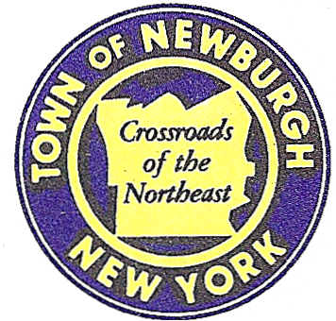

TOWN OF NEWBURGH
_______Crossroads of the Northeast __________________________
OLD TOWN HALL
308 GARDNERTOWN ROAD NEWBURGH, NEW YORK 12550

PLANNING BOARD
JOHN P. EWASUTYN, CHAIRMAN
TELEPHONE 845-564-7804
FAX 845-564-7802
E-MAIL: planningboard@townofnewburgh.org

PLANNING BOARD AGENDA

November 2nd, 2017

*PLEASE NOTE: The Planning Board Meeting will start at 7:00 P.M. and all Applicants/Representatives
are to be present at that time. The Meeting will be held in the Meeting Room of Town Hall,
located at 1496 Route 300, Newburgh NY.*

- McDonalds (17-26) INITIAL APPEARANCE
65 North Plank Rd. (Rt. 32) AMENDED SITE PLAN
Section 1, Block 1.1, Lot 76
Zone: B
Rep: Bohler Engineering
35 Technology Dr.
Warren, NJ 07059

2. Mobilitie (17-23) WIRELESS FACILITY
6 Orr Ave. SITE PLAN
Section 96, Block 1, Lot 11.1
Zone: IB
Rep: Paul Costa

3. All Granite & Marble (11-14) SITE PLAN
Brookside Farm Road PROJECT STATUS DISCUSSION
Section, 97; Block, 1; Lot, 20.2
Zone: IB
Rep: Justin Dates, RLA
Maser Consulting, PA
1607 Route 300, Suite 101
Newburgh, New York 12550

*WORK SESSION*
Project Readiness Discussion scheduled for 5:30 p.m. in the Meeting Room of
Town Hall on Thursday, November 2nd, 2017.*

4. Beretta Subdivision (17-21) 2 LOT SUBDIVISION
Old Post Rd. & River Rd.
Section 8 , Block 1, Lot 38.
Zone: AR & I
Rep: Maser Consulting
555 Hudson Valley Ave. Suite 101
New Windsor, NY 12553

PLANNING BOARD BUSINESS
WORK SESSION

- Trinity Square (08-07) Requesting a six month extension from November 2, 2017
to May 2, 2018.

*WORK SESSION*
Project Readiness Discussion scheduled for 5:30 p.m. in the Meeting Room of
Town Hall on Thursday, November 2nd, 2017.*

